Research Template Using Guide

by Robert ([kimimeng2013@gmail.com](mailto:kimimeng2013@gmail.com))

1. Copy researchTemplate.html as ‘name’.html , better to be acronym as its name and save in current working directory.
2. Open that html file using whatever editor you like, if you don’t have, I will provide a good editor link in resources->links, the sublime text 2 (free).
3. Same time, open that html file using a browser, chrome, safari, etc. it should be like that:

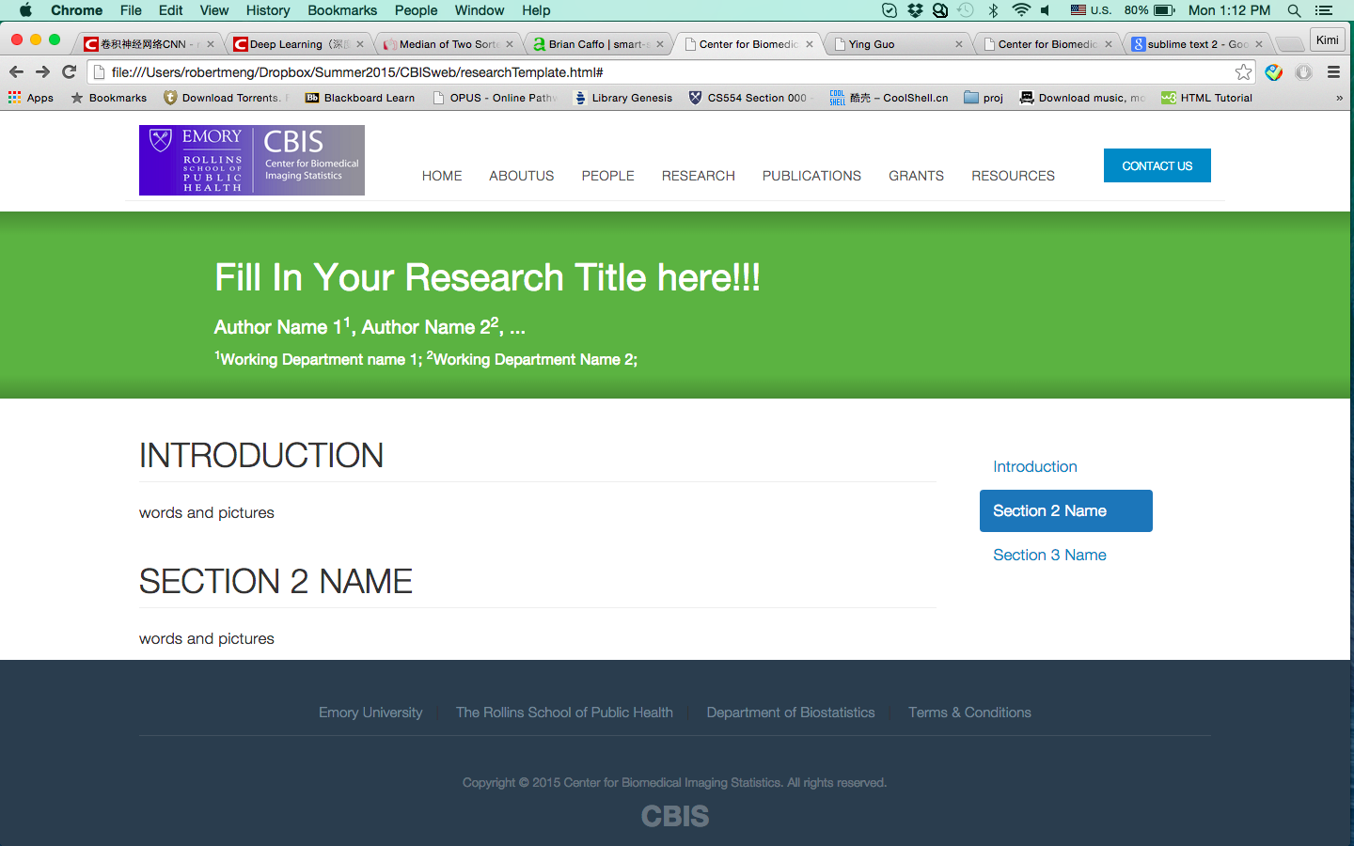

1. Find comments <!-- step 1 begins: -->, change your title, authors’ name and working department based on the comments until <!-- step 1 over: -->, save html file and refresh website on browser, it should be like that:



1. Find comments <!-- step 2 begins: -->
2. The first section id as ‘Introduction’ can’t be changed; other sections’ id and name could be updated, as you need. But these ids would be used in step 3 and link to side navigation.
3. Add content after comments <!-- add content you need based on guide --> and before </div> tag. Delete the lane before it <p>words and pictures</p>…
4. When you want add simple words, put a <p> tag before these words and a </p> tag after these words. No pictures, no complicate equations.

If some symbols need like &, < and >, use &amp, &lt and &gt instead.

Change line is <br> tag.

1. When you want add pictures like image results and equations (equation as a picture is much easier), 1. Edit your picture using whatever tools you like and save it as name.jpg/png to folder “./images/research”. 2. In html file, add code

<img src=”path/to/pictures.png” width=”number” />

hint: max width is 850, greater than 850 would cause error. Adjust width based on your need. Check its size by refreshing website.

hint: don't use high resolution pictures, cuz it will lead to a very slow web load rate.

hint: don’t intersect words <p> </p> and <img />, it might cause error sometimes.

1. If list is necessary ( like:
2. words and pictures
3. words and pictures
4. …

)

add code below:

<ol>

<li>

<!-- add content 1 here based on 3) and 4) -->

</li>

<li>

<!-- add content 2 here based on 3) and 4) -->

</li>

<li>

<!-- add content 3 here based on 3) and 4) -->

</li>

</ol>

hint: don't forget every close tag, like </p> </li> </ol>…

1. modify html until <!-- step 2 over --> comments, save html file and refresh website, it should be like that:

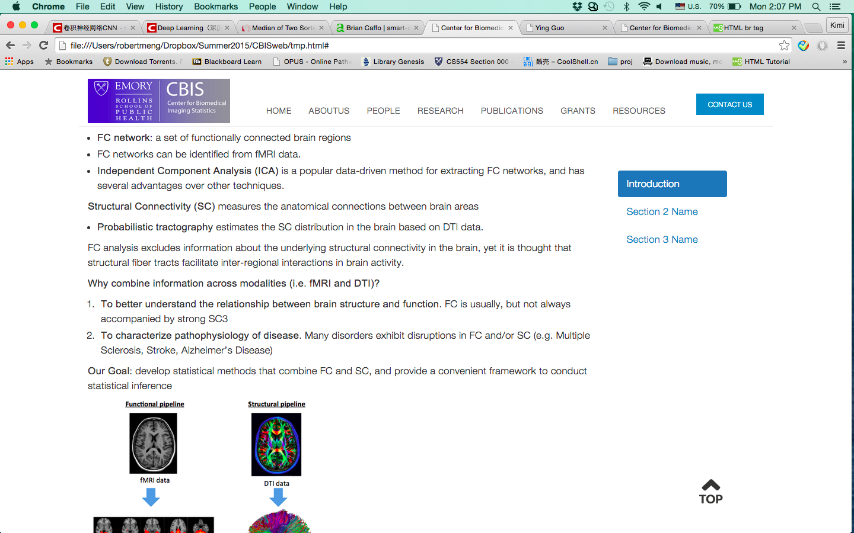

1. Find comment <!-- step 3 begins: -->
2. don't change content of first list item, important!!!
3. modify the rest list items, update its link as <a href=”newSectionId”> based on what you named it on step 2 , up date its section name on side navigation same with your content.
4. if necessary, add items.

until comment <!-- step 3 over --> save html file and refresh website, it should be like that:

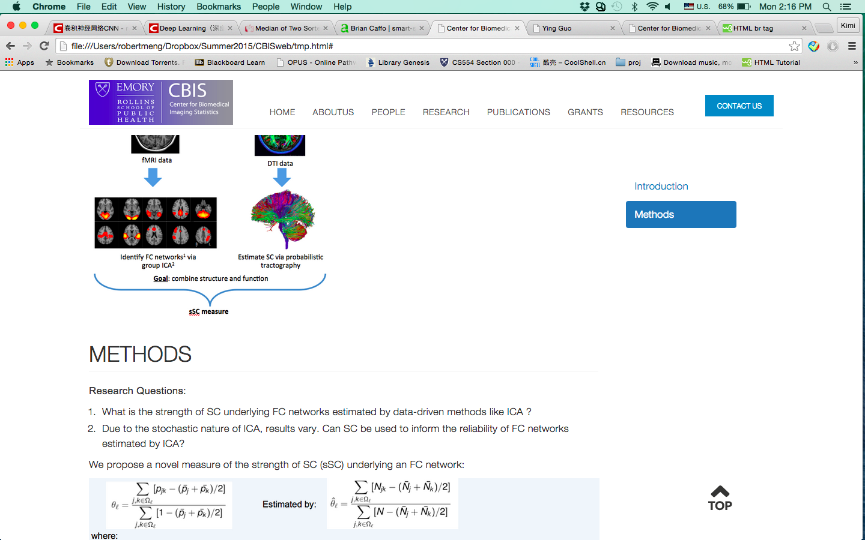

1. Done, congrats. If you have any question, please contact Robert ([kimimeng2013@gmail.com](mailto:kimimeng2013@gmail.com)).